# TRAFFIC MANAGEMENT SYSTEM

# TEAM MEMBER

710621106018: A.VINCENT RAJ

**PROJECT**: TRAFFIC MANAGEMENT SYSTEM

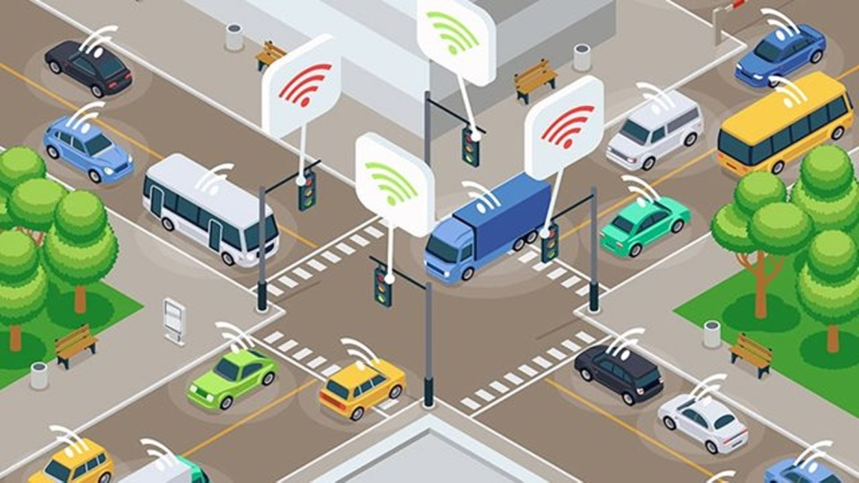

**OBJECTIVE**

The objective of a traffic management system using IoT is to ensure smooth mobility by providing real-time updates on traffic congestion and unusual incidents. The system can also send pre-alerting messages to prevent and delay road congestion. These systems use technologies like wireless connectivity and intelligent sensors. They can connect roadside devices to enable vehicles to communicate directly with intersections. The systems can be designed to control traffic congestion and track the number of vehicles. They can also be maintained easily

**PHASE -1**

With an ever-increasing population growth in cities around the world, continuous production of all kinds vehicles by manufacturers, and the number of vehicles on the roads will only continue to rise. This naturally leads to increased traffic congestion, especially in large metropolitan areas and even more so during peak rush hour time. This phenomenon constantly puts pressure on researchers, city officials, and urban planners to continue to improve traffic management systems in ways that are safer and economically more efficient. In order to address this evolving problem, a number of studies have been conducted that have resulted in some notable improvements such as designated lanes for emergency vehicles in urban areas. However, even with these lanes, often the ideal target-times for emergency vehicles to reach their destinations is hard to achieve. A new method which seeks to address this issue is called Intelligent Transportation System (ITS). This method can help solve the problem by integrating existing technology with the current infrastructure. In this paper, our goal is to compare different methods for managing traffics, namely Traffic Light Systems (TLS): Static and Dynamic TLS, Radio Frequency Identification (RFID), and Internet of Things (IoT). In the latter method, traffic data are quickly acquired and sent to Big Data for processing and mobile applications AKA User Interface (UI) to estimate traffic density in various areas in order to suggest alternative ways to alleviate traffic

CIRCUIT DIAGRAM:

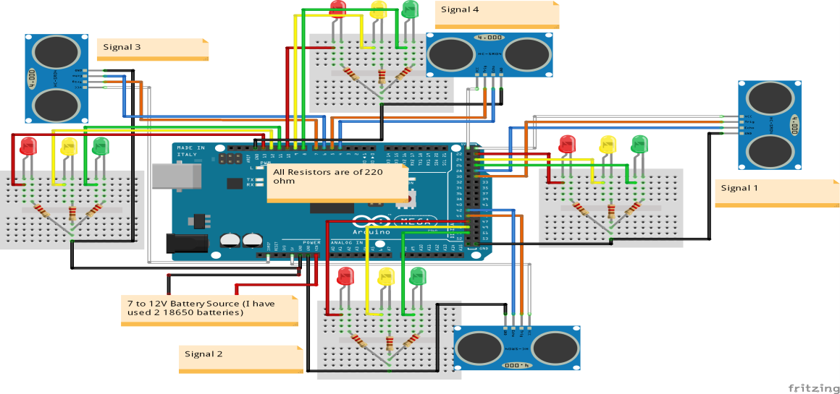

COMPONENTS REQUIRED

* Arduino Mega 2560
* 4 HC-SR04 ultrasonic sensors
* 4 red LEDs
* 4 green LEDs
* 4 yellow LEDs
* 12 220 ohm resistors
* Jumper cables
* Breadboards

MEHODOLGYSmart traffic management systems use Arduino to control traffic lights based on traffic density. The system uses infrared (IR) sensors to detect the number of vehicles passing through a junction. The sensors are placed on each side of the junction and interfaced with the Arduino. The Arduino receives input from the sensors and changes the traffic lights as needed.

PROBLEM

Some challenges of using the Internet of Things (IoT) for smart traffic management systems include:

* Cost: Sensors are expensive to install and maintain.
* Accuracy: Sensors may be inaccurate, especially in unfavorable conditions.
* Limited access: Private companies may have difficulty accessing data owned by municipalities.
* Limited coverage: Information is only available in locations where sensors have been placed.
* Security and privacy: IoT may pose security and privacy concerns.
* sensors: Infrared These sensors only work for shorter distances, so they may provide inaccurate data during heavy traffic congestion.

**FUTURE SCOPE**

* The future of smart traffic management systems using IoT could include:
* Traffic management systems that automatically control the flow of autonomous vehicles
* Ambulances that can communicate with base stations to get a free lane
* Smart ambulances that can send patient status to the hospital
* Different priority levels for multiple incidents and scenarios
* IoT in traffic management can save cities time, money, and resources. It can also make public transport safer and more convenient. However, there are challenges to integrating IoT with traffic networks, including:
* Network infrastructure costs
* Retrofitting vehicles or machines to be directly connected to an IoT device
* Implementation downtime
* Configuration, customization, training, and security
* Planning, implementing, and managing the IoT system

CONCLUSION

Smart traffic management systems use IoT technology to help cars spend less time idling. The systems enable traffic signals to communicate with each other and adapt to changing traffic conditions in real time. This can lead to less time spent in traffic jams and reduced carbon emission